DATE: 26.07.2019
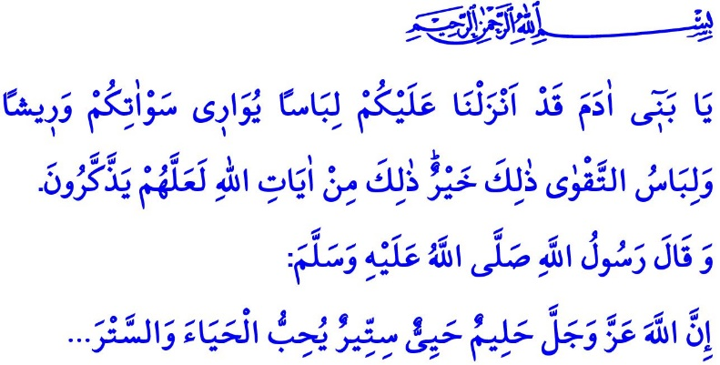
PHYSICAL PRIVACY AND ISLAMIC DRESSING
Honorable Muslims!
In the verse I have just recited, the Almighty Allah (swt) states, “O Children of Adam! We have provided for you clothing to cover your nakedness and as an adornment. However, the best clothing is righteousness. This is one of the signs of Allah, so perhaps you will be mindful.”
In the hadith I have just read, the Prophet Muhammad (saw) says, “Allah is modest and decent, and He covers up flaws. He loves decency and dressing (tasattur)…”
Honorable Muslims!
Our bodies, just like our souls, are great blessings bestowed upon and entrusted to us by Allah (swt). Every believing man and every believing woman is obliged to protect it. In this respect, our bodies, just like all blessings bestowed upon us, have rights over us. All believers in the know of the value of the blessings should use their bodies in the way of doing good deeds and helping spread the good. For there will come a day when we all will be questioned about for what purposes we have used our physical strength, beauty and handsomeness, and skills in the world.
Honorable Believers!
On top of the responsibilities towards our bodies comes covering it and protecting it from unallowed eyes, and bad words. Before everything else, it is a religious obligation to cover up one's body. It is also an innate and natural need to do so.
Dressing up one’s body is done primarily for one's own good other than for others. It is a demonstration of one's self-respect and protection of privacy. Covering up one's private parts reflects one's decency and attentiveness to the body. A specific feeling felt by humans only, decency stems from faith, as expressed by the Prophet Muhammad (saw). Covered up in a piece of cloth and entrusted to the mother after birth, humans are washed clean under another piece of cover and buried shrouded after death.
Honorable Muslims!
Just as to their bodies, Muslims need to show the same respect to other people. Not only do they need to
cover up their bodies against unallowed and unpermitted stares by other people, they also need to respect their privacy. Aware of their boundaries, they should not disturb other people with their stares. The line "It is a spiritual merit to look at beautiful women!" widely used colloquially has no place in Islam. For all persons have the right to privacy, regardless of their appearance. In this respect, the Almighty Allah (swt) warns Muslims as follows:
“Tell the believing men to lower their gaze and guard their chastity. That is purer for them. Surely Allah is All-Aware of what they do.”
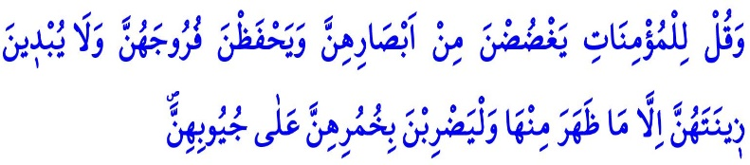
“Tell the believing women to lower their gaze and guard their chastity, and not to reveal their adornments except what normally appears. Let them draw their veils over their chests.”
As clearly stated in the verses above, the Almighty Allah (swt) asks all believing people, man or woman, to pay attention to decency and privacy. He declares that turning our gazes from haram and paying attention to dressing (tasattur) are duties upon us. Men's clothes that fit so tightly, thereby also threatening the physical health, are in violation of Islamic dressing. The awareness of Islamic dressing is not only about covering up the body, but also covering up and protecting the heart and mind against all kinds of evil, extremism, and what is forbidden (haram).
Honorable Believers!
Decency is a highly valued virtue that beautifies all people. The inviolability of decency is a shared value for all people. Due diligence to it makes both women and men respectable in the same way. For all persons, whether woman or man, deserve respect.
Dear Believers!
Paying attention to privacy is a requirement of piety (taqwa), namely the sense of respectfulness and respectability towards Allah (swt). Then, let us not let weaken the connection between us and Him, who blessed us with our bodies. Let us struggle to live a life He would approve and appreciate. Let us be aware that our bodies are sacredly inviolable, and our souls graceful and respectable. Let us instill self-confidence through the sense of privacy in our family members and particularly our children from early ages on. Let us not forget that virtuous societies are formed by people who protect their moral, spiritual, and cultural values.

A’raf, 7/26.
Nasa'i, Ghusl, 7.
Nur, 24/30.
Nur, 24/31. General Directorate of Religious Services

